Elevate labs task 6

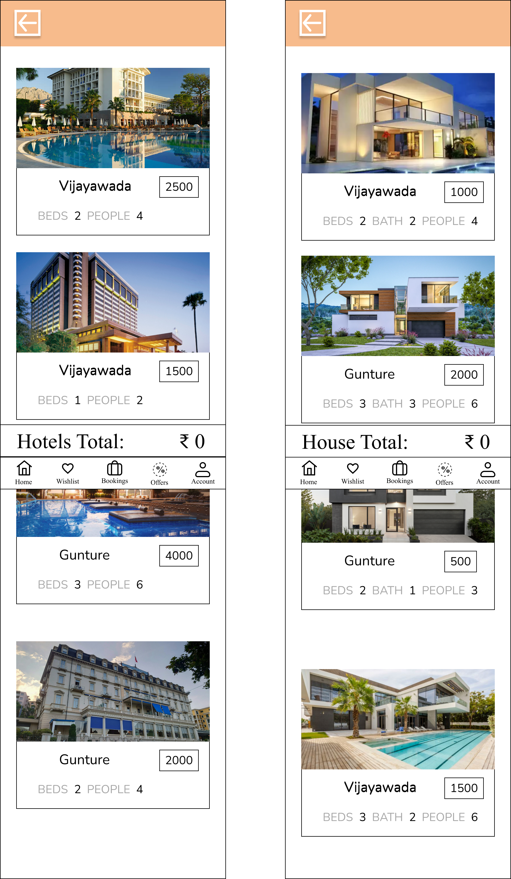

After conducting user surveys, I found that users were frustrated with the large card layout and the lack of product information. To address this, I redesigned the interface by displaying two cards side by side and including complete details for each rental item, improving both visibility and user satisfaction.

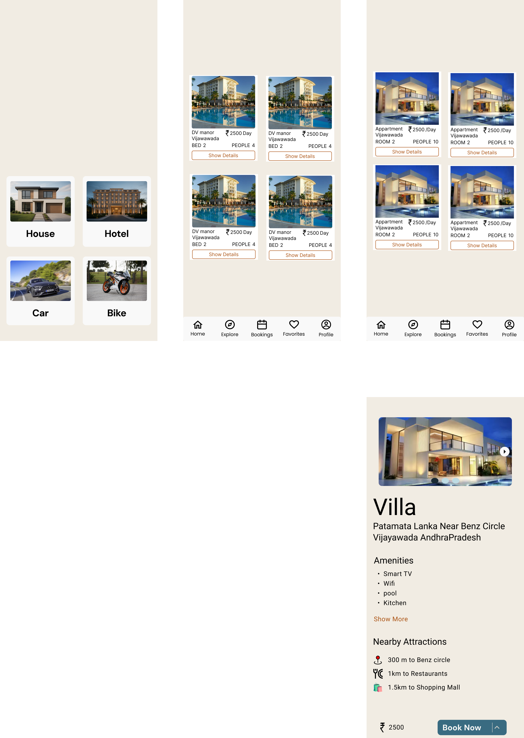

https://www.figma.com/design/tlvYRUPeYaqrFASB9nYf4X/vacation-rentals?node-id=52-8&t=VIIOtpXrVhpL2h2k-1